**NAME:**

**Family Tree**

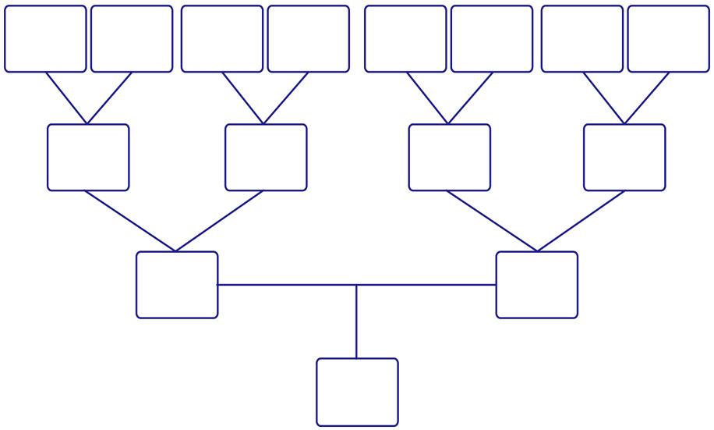

Me

Dad

Mom

Paternal Grandfather

Paternal Grandmother

Maternal Grandfather

Maternal Grandmother

Great Grandmother

Great Grandfather

Great Grandmother

Great Grandfather

Great Grandmother

Great Grandfather

Great Grandfather

Great Grandmother